EE052
PRINCIPLES OF EE1 LAB

Lab 6

Mesh and Nodal Analysis
of AC Circuits

Full name: ……………………………………………
Student number: …………………………………….
Class: ………………………………………………....
Date: ………………………………………………….

- OBJECTIVES
After completing this experiment you should be able to:
- Verify experimentally the AC mesh-current technique.
- Verify experimentally the AC node-voltage technique.
- Generate an AC source using a phase-shifting network.
- INTRODUCTION

This laboratory experiment explores two different techniques to solve AC circuits: mesh-current and node-voltage. In the first section, we are going to experimentally measure the mesh currents of an AC circuit that has been previously calculated in the Pre-Lab using the AC mesh-current method. In a similar fashion, the second section corroborates the node-voltage technique by comparing the experimentally measure node voltages with the node voltages calculated in the Pre-Lab using the node-voltage method.
- PRE-LABORATORY
Part 1: Mesh-current Analysis
Mesh-current analysis is a widely used method to solve AC electric circuits. This method is particular useful when circuits contain more than one source. The AC mesh-current method, like the DC mesh-current method, is based on Kirchhoff’s voltage law around each closed loop. Once all the independent equations are obtained, they are solved simultaneously for the loop currents. The rules for setting up and performing AC mesh-current analysis are the same as those for DC mesh-current analysis. Remember, equations must be solved using phasors and phasor algebra (i.e. all complex numbers).
- Using the mesh-current technique calculate the mesh current I₁ and I₂ of the circuit shown in Figure 1. Assume C₁ = 0.01 μF, R₁ = 22 kΩ, R₂ = 10 kΩ, C₂ = 0.01 μF, f = 500 Hz, V₁ = 5 V, and V₂ = 3.37 V lagging 46˚ with respect to V₁. Express the results in phasor form (i.e. magnitude and angle). Show all your calculations. Using the calculated mesh current, calculated the voltage drop in each impedance (V_{Z1}, V_{Z2}, and V_{Z3}). Using these results complete Table 1 on the Laboratory Data Section.
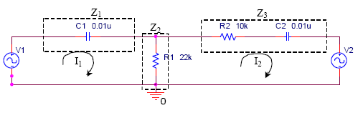
Figure 1. AC network used in the mesh-current analysis
- Using Electronic Workbench, run a transient simulation (from 0 to 10 ms) of the circuit shown in Figure 1.
  - Plot on the same graph the input voltages V₁ and V₂. Make sure that the magnitudes of V₁ and V₂ are corrects (be careful with peak and peak-to-peak values) and that V₂ lags V₁ by 46˚.
  - Plot on the same graph the input voltage V₁ and the voltage across Z₁. Using the cursors of Probe, measure the magnitude and phase of the voltage drop cross Z₁. Use this value to complete Table 1.
  - Plot on the same graph the input voltage V₁ and the voltage across Z₂ and measure the magnitude and phase of the voltage drop cross Z₂. Use this value to complete Table 1.
  - Plot on the same graph the input voltage V₁ and the voltage across Z₃ and measure the magnitude and phase of the voltage drop cross Z₃. Use this value to complete Table 1.
  - Plot on the same graph but under different y-axis the input voltage V₁ and the mesh currents I₁ and I₂. Measure the magnitude and phase of each mesh current. Complete Table 2 on the Laboratory Data Section.
  - For the circuit presented in Figure 2, mathematically obtain the output voltage V₂. Express V₂ in phasor form. Show all your calculations. Assume R₃ = 330 Ω, C₃ = 1μF, f = 500 Hz, and V₁ = 5 V rms.
  - Using PSpice, run a transient simulation (from 0 to 10 ms) for the circuit shown in Figure 2. Plot on the same graph the input voltages V₁ and output voltage V₂. What is the magnitude of V₂? What is the phase difference between the input voltage V₁ and the output voltage V₂? Express V₂ in phasor form and compare with the output voltage calculated in f.
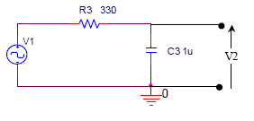
Figure 2. Phase-shifting network

Part 2: Node-voltage Analysis

Like DC circuits, node-voltage or nodal analysis of AC circuit is based on Kirchhoff’s current law. The procedure for setting up and solving an AC circuit by the node-voltage method is the same as that for DC circuits. Remember, that equations must be solved using phasors and phasor algebra.
- Using the node- voltage method calculate the node voltages V₁₁ and V₂₂ of the circuit presented in Figure 3 where R₁ = 1 kΩ, C₁ = 0.22 μF, R₂ = 1 kΩ, C₂ = 0.22 μF, R₃ = 1 kΩ, f = 500 Hz, and V₁ = 5 V. Express the results in phasor form. Show all your calculations. Use these results to complete Table 3 on the Laboratory Data Section.
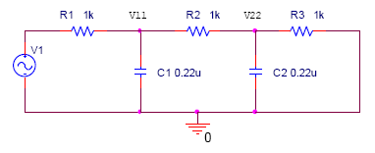
Figure 3. AC circuit used in the node -voltage analysis

- Run a transient simulation (from 0 to 10 ms) for the circuit shown in Figure 3.
  - Plot on the same graph the input voltage V₁ and the node voltages V₁₁ and V₂₂. Measure the magnitude and angle of the node voltages V₁₁ and V₂₂. Use these results to complete Table 3 on the Laboratory data section.
  - Obtain the phasor form of the simulated node voltages V₁₁ and V₂₂. Compare them with the phasor form of node voltages V₁₁ and V₂₂ calculated in 3 above.
- EQUIPMENT AND PARTS LIST
  - Dual-trace oscilloscope.
  - Waveform generator.
  - 330 Ω, 1k Ω and 22k Ω resistors.
  - 0.01 μF, 0.22 μF and 1 μF capacitors.
  - Breadboard.
  - Connecting wires.
- PROCEDURES
- Construct the AC circuit shown in Figure 4 below.
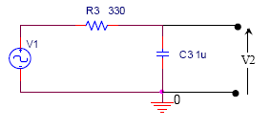
Figure 4. Phase-shifting network
- Stimulate the circuit with a sinusoidal waveform generator using a frequency of 500 Hz and 5 V. Using the oscilloscope, connect Channel 1 across the input voltage source V₁ and Channel 2 across the output V₂. Measure V₂ magnitude and phase.
V₂ = 3V Δt = 240μs T=0.002s
Phase = 43.2
- When setting up a laboratory procedure to verify the mesh-current analysis, it is not practical to use two different signal generators in the same circuit. Remember that phasor algebra is based on the assumption that all currents and voltages have identical frequency. However, a signal generator tends to have frequency drift (i.e. the output frequency of the generator changes with time); therefore, it is not possible for two generator to produce exactly the same frequency over a long period of time. In order to overcome this we ‘simulate’ a second source using a phase-shifting network delay. The circuit shown in Figure 1 is practically implemented as shown in Figure 5. Construct the AC circuit shown in Figure 5. Stimulate the circuit with a sinusoidal waveform generator using a frequency of 500 Hz and 5 V.
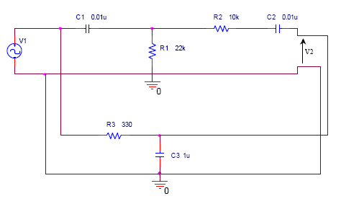
Figure 5. Practical implementation of the circuit shown in Figure 1

- Measure the input voltages V₁ and V₂. Make sure that the magnitudes of V₁ and V₂ are corrects (i.e. be careful with peak and peak-to-peak values) and that V₂ lags V₁ by 46˚.
V₁ = 5V
V₂ = 3V
Δt = 260μs T=0.002s Phase = 46.8
- Use channel 1 to measure the input voltage V₁. Use channel 2 and a differential voltage probe, measure the voltage across Z₁. Use these results to complete Table 1. Remember to measure magnitude and phase.
V_{Z1} = 3.35V
Δt = 160μs T=0.002s Phase = 28.8
- Using channel 1, measure the input voltage V₁. Using channel 2 and a differential voltage probe, measure the voltage across Z₂. Complete Table 1.
V_{Z2} = 3.2V
Δt = 160μs T=0.002s Phase = 28.8

- Use channel 1 to measure the input voltage V₁. Use channel 2 and a differential voltage probe, measure the voltage across Z₃. Complete Table 1.
V_{Z3} = 1.72V
Δt = 100μs T=0.002s Phase = 18
- Use channel 1 to measure the input voltage V₁. Use channel 2, a differential voltage probe and a “testing” resistor to measure the mesh currents I₁ and I₂. Use these result to complete Table 2.
I₁ = 0.105 mA I₂ = 0.04 mA
- Construct the circuit shown in Figure 6 below.
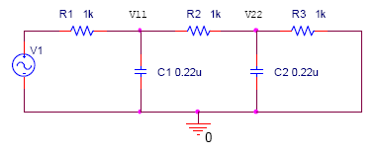
Figure 6. AC circuit used in the node -voltage analysis
- Stimulate the circuit with a sinusoidal waveform generator using a frequency of 500 Hz and 5 V. Using the digital oscilloscope, connect Channel 1 across the input voltage source V₁.
- Use a second voltage probe on channel 2, in order to measure the node voltage V₁₁. Record the magnitude and the phase. Complete Table 3.
V₁₁ = 2.55V
Δt = 220μs T=0.002s Phase = 39.6
- Measure the node voltage V₂₂. Record the magnitude and the phase. Complete Table 3.
V₂₂ = 1.2V
Δt = 320μs T=0.002s Phase = 54

- Post-Laboratory
- Mesh-current Analysis:
- Complete Table 1 with the obtained values. Use phasor form (i.e., magnitude and angle).
- Compare the errors between calculated and simulated values, calculated and measured values, and simulated and measured values. Draw a conclusion about the accuracy of your simulation and measurements with respect to your calculation.
- Complete Table 2 with the obtained values. Use phasor form (i.e., magnitude and angle).
- Compare the errors between calculated and simulated values, calculated and measured values, and simulated and measured values. Draw a conclusion about the accuracy of your simulation and measurements.

- Node-voltage Analysis:
- Complete Table 3 with the obtained values. Use phasor form (i.e., magnitude and angle).
- Compare the errors between calculated and simulated values, calculated and measured values, and simulated and measured values. Draw a conclusion about the accuracy of your simulation and measurements.

Laboratory Data Section

Table 1: Mesh-Current Analysis
 | Calculated | Simulated | Measured
V_{Z1} [V] |  |  | 3.35
V_{Z2} [V] |  |  | 3.2
V_{Z3} [V] |  |  | 1.72

Table 2: Mesh-Current Analysis
 | Calculated | Simulated | Measured
I₁ [mA] |  |  | 0.105
I₂ [mA] |  |  | 0.04

Table 3: Node-Voltage Analysis
 | Calculated | Simulated | Measured
V₁₁ [V] |  |  | 2.55
V₂₂ [V] |  |  | 1.2

